**Cabling Guide**



We are using the T568**A** wiring scheme:

**How to Crimp RJ45 Plugs**

1. Strip about 4cm of the outer insulation using the yellow cable stripper. Be careful not to nick the inner wires. If you do, cut the end off and start again.
2. Untwist and separate all the pairs, making the wires as straight as possible (Don’t worry about keeping twists, this is solved later).
3. Push the wires through the miniature guide piece. Make sure you have the guide the right way up! The gaps should be on the top, you should push the wires into the fatter end, and pin 1 is on the left at the top.
4. Push the guide down the wires as far as it will go.
5. Cut off the ends of the wires right where they exit the guide. You can use the cable cutter at the bottom of the green crimper for this.
6. Push the guide into the RJ45 plug as far as it will go.
7. Push the RJ45 plug into the green crimper as far as it will go, and squeeze as hard as you can.
8. Repeat for the other end and test with the cable tester. The lights should come up reliably in sequence. If you’re using an EMF-supplied tester, the lights can be checked at either end.
9. Label the cable using a sharpie – If you’re running from DK-S1 to DK-S2, the cables at the S1 end should be labelled “S2-1” and “S2-2”, and at the S2 end should be labelled “S1-1” and “S1-2”. If you can’t write small enough, make a flag from white insulating tape and write on that instead.

**Copper Notes**

The red cable is proper copper, and should only be used for the links marked red on the cabling diagram. The other links can use the grey CCA cable.

When running pairs of Cat5e between locations, if possible please run the two cables via different routes (to minimise the likelihood of an outage from a single cable cut).

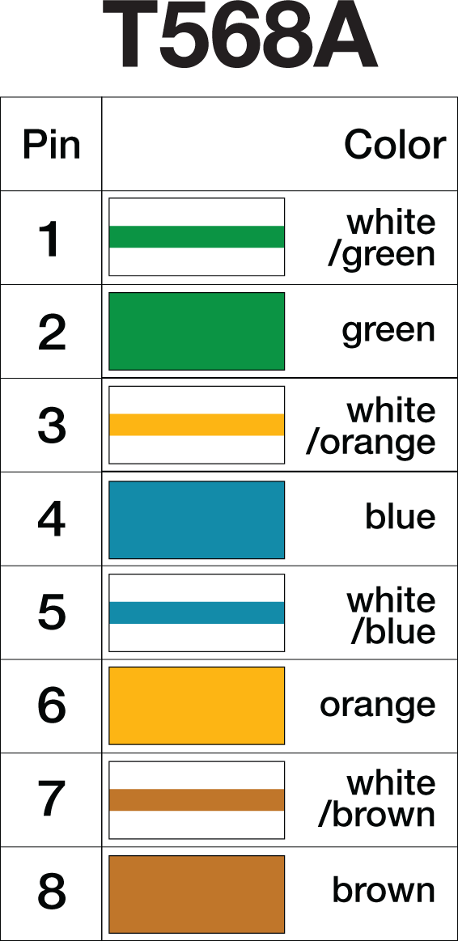

**Fibre Notes**

When running fibre, the reel should be stored in the end furthest from the core (there is more space in the remote DKs).

Before plugging in the fibres, they need to be cleaned. Please don’t plug them in unless you have the cleaning kit – we were charged for optic cleaning last time.

Please place all fibre caps and SFP plugs into the plastic bag supplied, so they can be put back on during tear-down.

Nine out of ten network issues at hacker camps are caused by bad crimps[*citation needed*].

Our new two-piece RJ45 plugs make crimping a doddle. We also have traditional plugs for experienced crimpers only. Crimpity-crimpity-ping-pong.

|  |  |  |
| --- | --- | --- |
| C:\Users\david.croft\Documents\Dropbox\emfcamp2014-noc\printouts\crimping\done\IMG_0022.jpg | C:\Users\david.croft\Documents\Dropbox\emfcamp2014-noc\printouts\crimping\done\IMG_0023.JPG | C:\Users\david.croft\Documents\Dropbox\emfcamp2014-noc\printouts\crimping\done\IMG_0025.JPG |
| C:\Users\david.croft\Documents\Dropbox\emfcamp2014-noc\printouts\crimping\done\IMG_0029.JPG | C:\Users\david.croft\Documents\Dropbox\emfcamp2014-noc\printouts\crimping\done\IMG_0032.JPG | C:\Users\david.croft\Documents\Dropbox\emfcamp2014-noc\printouts\crimping\done\IMG_0035.JPG |
| C:\Users\david.croft\Documents\Dropbox\emfcamp2014-noc\printouts\crimping\done\IMG_0037.JPG | C:\Users\david.croft\Documents\Dropbox\emfcamp2014-noc\printouts\crimping\done\IMG_0041.JPG | http://www.structuredhomewiring.com/Images/WiringCat5PlugA.gif |